PartA: Data Acquizition and Understanding

Domain: E-commerce / Retail Sales Analytics
Business Problem: Analyze global sales performance, identify profitable markets,
understand return patterns, and optimize regional operations

Dataset Source: Kaggle Global Superstore Dataset
URL: [ https://www.kaggle.com/datasets/rohitgrewal/global-superstore-data?resource=download]
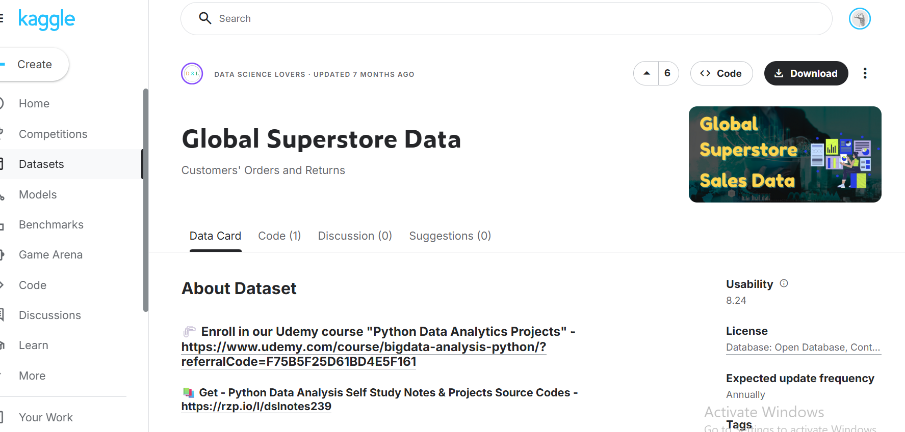

Key Tables:
- Orders (51,290 rows): Fact table containing all transactions
- Returns (2,033 rows): Returned order records
- People (24 rows): Sales representatives by region

Variables include:
- Categorical: Category, Segment, Market, Region
- Numerical: Sales, Profit, Quantity, Discount
- Date: Order Date, Ship Date

Rich dataset with time intelligence potential, multiple dimensions,
return analysis capability, and sufficient row count for advanced analysis.

Confirmation of 3 Tables and data loaded:
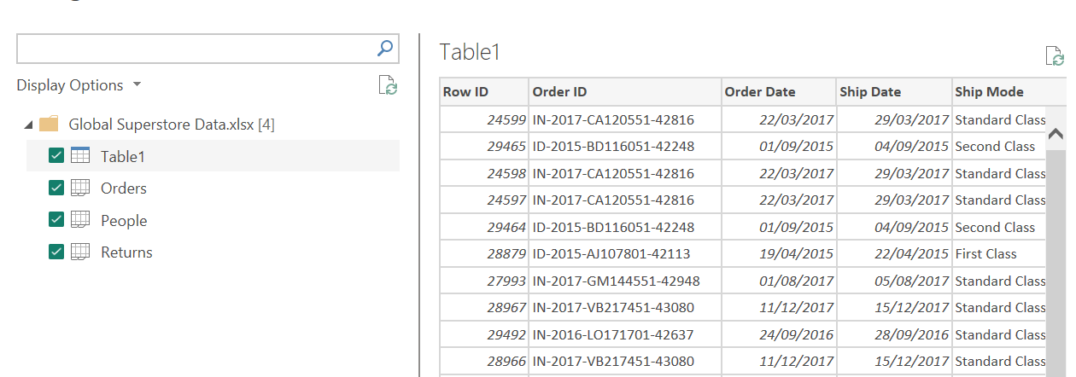

Part B: Data Cleaning and Transformation in Power Query

Cleaning Orders Table

